**Program -1**

**ONE-WEEK INTERNATIONAL WEBINAR ON**

**“SUFFERING SURFACE OF WOMEN EMPOWERMENT”**

**DAY 1 – SESSION - I**

**THE GROWTH OF WOMEN EMPOWERMENT IN VIRTUAL ERA**

**Date:01.09****.2020 TIME:10.00 a.m -11.30 a.m**

**No.of. beneficiaries: 84**

Women’s Studies Centre of Madurai Kamaraj University, Madurai and Department of English, Nagarathinam Angallammal Arts and Science College, Madurai in collaboration with University Grants Commission conducted a one-week International webinar on “Suffering Surface of Women Empowerment. The first day of the webinar began with the welcome address by Dr. Sevvel, Principal, Nagarathinam Angallammal Arts and Science College. He in his welcome address welcomed Prof. Dr.M.Krishnan,Vice- Chancellor of Madurai Kamaraj University,Dr.R.Radhika Devi, Director-in-Charge,Women’s Studies Centre, Madurai Kamaraj University,Dr.N.Jegatheesan Secretary NagarathinamAngallammal Arts and Science College. After the welcome address the Inaugural Address was delivered by Prof.Dr.M.Krishnan, Vice-Chancellor of Madurai Kamaraj University after the welcome address. The vice chancellor mentioned about raise in incidents of women harassment in newspapers. Women have to play a major role in disaster like COVID 19 in taking care of both, the members in the family and society. The Vice-Chancellor concluded by saying the women’s studies Centre should reach the villages to take care of women in villages, their economic development and bring out rural women in various aspects. The inaugural address was continued by presidential address. The presidential address was delivered by Dr.N.Jegatheesan, Secretary,NagarathinamAngalammal Arts and Science College. He in his presidential address mentioned that suffering surface of women has global impacts. Women throughout the world are facing different forms of abuse. Inspite of struggles, women are achieving in the field of business and concluded by saying that we should work together for a Gender just society and ensure the sustainable development of society. The presidential address was followed by the special address by Dr.Muthmainnah S.PDI.M.PD, Director, Centre for Women’s Studies, Lecturer Teacher Training and Education Ai Asyariah Mandar University, West Sulaweshi, Indonesia on the topic “The Growth of Women Empowerment in Virtual Era”. In her speech she commented that we all are living in the virtual era and our activities are controlled by internet. The information is reaching us faster. Many academic institutions like university of California, Indonesian foundation are teaching the ways to women on empowering through social media. The idea of the vice chancellor on reaching women in villages and empower them through education and entrepreneurial activities is the need of the hour. Women should make themselves more self-reliant in using digital devices. Dr.Muthumainnah further said that we should pay more attention towards easy accessing of digital services to women. Women are still a passive recipient of information and they need to be developed. Capacity building and improving the skills to women in using Information Technology should be developed by both the state and central Governments. The women are still lacking in accessto resources on par with men. The digital empowerment of women leads to social, political economic empowerment of women. Women must be taught to use properly the internet for their educational purposes. With education women can achieve things whatever they want. As the digital revolution unfolds and the content and nature of jobs change, so do the skills required to perform them change. Solid cognitive skills, coupled with the ability to solve problems and to learn and think creatively, are key steps in adapting to the scale, speed and scope of digital transformations. We must think how far are women ready for digital transformation, upgradation in their education levels. Education gives women the problem-solving ability and other skills required for technology upgradation. Still many societies are following patriarchal system which hinders women development.Dr. Muthumainnah concluded her speech by saying that for every women education and upgradation of skills in women is a must. The morning session was turned to a discussion and the discussion was about percentage of women having access to internet. The Session ended with vote of thanks by Dr.VasanthaKumar, Department of English,NagarathinamAngallammal Arts and Science college, Madurai. He in his address thanked the resource person and the participants for attending the webinar.

**DAY 1 – SESSION - II**

**Date:01.09.2020 TIME: 11.45 a.m -12.45 p.m**

**No. of. beneficiaries: 84**

The second session began with the welcome address by Dr. Vasanthakumar, Department of English, NagarathinamAngallammal Arts and Science college, Madurai. He in his welcome address welcomed the resource person and participants for the webinar.Dr.NehaMisra ,Assistant professor, Government College Daman was the resource person for second session. She began her speech on the topic “impact of social media on women” by saying that the impact of social media has both and negative aspects on women. We can see the usage of some common terms in social media like cybercrime, cyber stalking, bullyingetc. The reason why we are speaking of these terms is the increase in usage of social media which became an easy platform for cyber criminals for illegal activities. Some of the popular social media are face book, WhatsApp, share chat. Women while using the social mediashould be careful and cautious in using it. They must be aware about the danger in using social media. The adolescent girls due to lack of awareness are trapped as victims of cyber-crime. This happens mainly due to arousal of curiosity at the adolescent age do not know the severity or ill effects of social media. The recent developments in social media gives importance to objectification as still women are viewed as sexual objects and becomes normal. Using women as sexual object is not a normal one. posting personal pictures in social media may it a known or unknown person is highly dangerous.Dr Mishra further continued to explain that, we have to be aware of cyberbullying as any two photos can be matched together and can be posted publicly. The cyber criminals can make use of the photos to threaten you not only photos but your personal details can be misused. Many follow celebrities in social media and want to become that particular celebrity, lookbeautiful like them and end up in depression. There is a concept called FOMO Fear of Missing in Social Media.Today youngsters are interested in taking selfies and there is a close relation in body dissatisfaction and social media. These has psychological impact on women and girls as naturally they give more importance how they are presenting themselves in front of others. In social media how others see them.Apps like Instagram has beautification options like whitening the face or making face more beautiful which gives more body dissatisfaction on the minds of girls. The website www.cyber.orgwe can see the document on usage of social media which consists of certain tips in using social media. To mention few, do not give friend request to unknown person and internet sites.When we download certain files from the internet, we should see the authentication of the file i.e., its private policy and then download the file.

Dr.Mishra further said to the participants that donot share or forward unverified news to others. Trolling is another issue which is seen as a lethargic issue but actions against trolling are taken seriously. We must not believe in unknown person in social media as people would give their fake identities. The social media has become the voice of many women today. If we are facing many problems, you should report the problems to cyber police. The statistics from NCRB-National Crime Records Bureau that the cases of Cyber Stalking of women have increased 36 percent from 2017 to 2018.542 cases were registered in the year 2017 739 in 2019.the reported cases in cybercrime have fell down in 28.3 % in the same time period. They don’t report due to fear of online violence. Once I have been a victim of cyber-crime, I have to quote to National Commission of Women or to cybercrime police. The ministry of Women and Child have email ID where we can complaints to complaint mwc@gmail.com. The National commission also have a mail id complaint cell -ncw @ac.in to register the complaints. National cybercrime reporting portal is the legal reporting and the mail id: cybercrime.gov.in. Hashtags are the tool for empowerment. Many complaints have been registered during the lockdown period as NCW has given Whats- App number to register complaints if women are in a trouble. The resource person ended her lecture by saying understand the good and bad in social media and use it. After the lecture in the feedback session questions on cyber bullying, laws for women related to cyber-crime were discussed. Dr.Chitra Devi delivered the vote of thanks in her vote of thanks she thanked the resource person and the participants for attending the webinar.

**Day 2- Session-III**

**Date:02.09.2020 TIME: 10:30 a.m -11:30 a.m**

**No. of. beneficiaries: 84**

Women’s Studies Centre of Madurai Kamaraj University, Madurai and Department of English, Nagarathinam Angallammal Arts and Science College, Madurai in collaboration with University Grants Commission conducted a one-week International webinar on “Suffering Surface of Women Empowerment.On the second day, the third session of the international webinar began with the welcome address by Dr .C.Subbulakshmi, Assistant Professor, Women’s Studies Centre,Madurai Kamaraj University,Madurai.She in her welcome address welcomed the resource person Dr.Neha Arora, Assistant Professor, Department of English, Central University of Rajasthan,India,and the participants for the webinar.After the welcome address the resource person delivered her special lecture on the topic“Breaking barriers and creating milestones”. She began her speech by saying empowerment means strengthening the individual and grooming him/her to develop wholesomely. Encouraging them or making them gain new skills for independent existence or overcoming socio-political -cultural-economic obstacles or putting an end to marginalization. Access to resources or decision-making power or liberty to have one’s own perspective.

According to the world bank, Gender Mainstream is one of the priorities in development projects. Empowerment is a “gendered project” but in case of Dalit women we must also accept caste as a barrier. The National policy of Empowerment of Women 2001 in the development policies and programme gave importance to mainstreaming in a gender perspective.Dr.Neha further spoke about Dalit Women by saying they are socially, economically, politically backward. Powerless in family, community and society. They face caste marginalization by women solidarity groups and sexual marginalization by Brahmanical patriarchy and Political Marginalization by Dalit men. We can alsoobserve Cultural marginalization in the male dominated Dalit literature. Ruth Manorama defines Dalit women’s oppressed status thus using Ambedkar’s earthen pots which says women are in a lower position of society and Dalit women are considered still lower than them. Gopala Guru talks about two patriarchal situations in which the Dalit Women gets pressure from both upper caste men and men from her own caste. The Dalit women are deprived of thedecision-making power and they are not educated in order to make them silence.Dr.Neha explained further by saying that Domestic Violence gets social sanction in “marriage”. The Brahminical concept of preferring male child over female exists. There is also disparity in the wages paid for outside work. In the Post Ambedkarite era the Dalit Women’s political participation declined. The Dalit panthers portrayed Dalit Women, encapsulated either in the role of mother or victimized as sexual being. Woman are considered as a source of ‘purity’, ‘honour’ for upper caste. The sexual subordination of women is institutionalized.The sexual availability of lower caste women is something that men and women of lower caste were forced to accept. The rituals or traditions exploit Dalit Women, the Devadasi system is an example. Thanthai periyar objected such kind of sexual exploitation. The females of the Shanar Community were in Travancore were not allowed to cover their breasts.The Dalit patriarchy can be seen in economic labour, sexual division of labour. The effects of Sanskritization cannot be overlooked. The upper caste norms percolate into the lower caste. The social or cultural norms and religion helped patriarchy to suppress or silence women. The Dalit men are robbed of their masculinity through caste and class hierarchies, they reassert it by patriarchal norms. The Dalit men commodify their women folk economically and sexually. We can observe exclusion of Dalit women in the context of politics of caste and gender. The Dalit women are seen as victims because of “Material Deprivation” and “political powerlessness”. There are plural feminist perspectives and feminism does not focus on single perspective. The need for Dalit feminism arose as the mainstream feminists did not take a grassroot approach and focus on the plight of Dalit women. The new concept in the Dalit literature “Dalit Womanism” which asserts Dalit woman’s identity, creates space for her voice and enables her to express her dissent against the mainstream discourse.

Dr.Neha quoted Dr.B.R.Ambedkar on women “I am conscious of the fact that if women are conscientized the untouchable community will progress. I believe that women should organize and this will play a major role in bringing an end to social evils…. The progress of the Dalit community should be measured in terms of the progress made by its women folk. Every woman should stand by her husband not as a slave but as his contemporary, as his friend”. Dr. Neha further described about how a new Dalit woman should be. The Dalit women is an activist in true sense and cannot be confined to one particular aspect alone. She includes herself in politics, Literature, performing arts and popular culture. The new Dalit women started to say no to the projected stereotypes image of victim woman. So, they write their own narratives through academics or literature or media. Thus, sharing their experience of resilience, constructing an independent space, changing their mindscapes and journeying from pain to power. The pre-independent India saw the active participation of Dalit women namely Jhalkari Bai, Uda Bai,Nangeli. We should not ignore Savitri bai phulewho set the foundation for women education, women rights. Ruth Manorama important Dalit Women leader who worked on legal actions to empower Dalit Women. She researched on manual scavenging and Devadasi system which is an organized crime against Dalit Women. She worked on comparing U.S.Women and Dalit Women in India. She conceptualized the term “triple alienated” or “thrice discriminated” and refers Dalit women as Dalits among Dalits. The resource person further explained that the conference on International Women’s day in Bangalore (1987) witnessed coming together of Dalit women and scholars from across the country. It was also attended by Afro American feminist, Jeane Zindab, who was then working in Geneva on a programme on Racism, Ethnicity and indigenous peoples. The conference was followed by the formation of many Dalit women’s groups spearheaded by leaders including Jyoti Raj, Prema Shantakumari, Rajini Tilak and Vimal Thorat.Dr.Nehafurther spoke that in August 11,1995 a Devadasi Women Yellamma travelled from Raichur District in Karnataka to Delhi and in the presence of over thousand Dalit Women, lit the inaugural lamp to establish the National Federation of Dalit Women (NFDW). It was started with a motto of transforming pain to power. The federation declared that Dalit women is a feminist, Non -Brahminical, Non-Patriarchal and positively oriented towards ecology. This was the beginning of their unanimous vision for their liberation and empowerment. Dr.Nehra further spoke about the Beijing platform for action in 1995 which had a delegation of over two hundred and fifty women out of which eighty were Dalit Women. In March 2006 the first national conference on Violence against Dalit Women took place in New Delhi passed the Delhi declaration which laid out how Dalit women faced “disparities in the prevalence of violence, poverty and sickness” and described the way the dominant castes were responsible for these disparities.

In November an international conference on the Human rights of Dalit Women was held at Hague. It was a significant platform to instill among Dalit women a sense of group solidarity. This was could be said as a base to start forums for Dalit women, like All India Dalit Mahila Adikar Manch or All India Dalit Women’s Rights forum was founded by Vimal Throat with Asha Kotwal as General secretary. The Dalit Women’s Network Solidarity (DAWNS) coined the term “Dalit Womanism” and focused on Rebuilding, Restoration and Reconciliation of all communities and emphasize on Education, Employment and livelihood for the overall development of Dalit community. The resource person further spoke about the conference on 2017 namely Dalit Women speak out conference which was a conglomeration of Dalit women from various arenas of life like sports, academics, corporate sectors, thinkers, artists. The social media campaign #Dalit Women fight was used by All India Dalit Mahila Adikar Manch (AIDMAM) to break the silence on caste apartheid and caste rape.“Project Mukthi” was found by a group of Adivasi Dalit women, which is a platform for all women to end caste apartheid. The Dalit history month was celebrated every year in the month of April in commensuration of the birth anniversary of Dr.B.R.Ambedkar which got implemented in the year 2015. Dr.Neha gave Thenmozhi Soundarajan and Sanghapali Aruna as an example of third generation Dalit activist.The resource person also highlighted about “agrofeminism” a concept introduced by Vedanayagi to develop the waste land as agricultural land to empower Dalit women. The paani panchayat was formed by Dalit women in 2011 from the areas of Uttar Pradesh. The major agenda of the panchayat was to access clean water. “Sangam” Asia’s first community Dalit women radio which broadcast in two hundred villages in Telangana. The Maha Dalit drum band, formed by Dalit women in patna. Ginimahi the famous Dalit pop singer, has her own music band named “chamar pop”.

RoshmitaHarimurthy, Indian model and beauty pageant title holder was the first scheduled caste winner of beauty pageant and won miss universe in the year 2016.In 2002 “Kabar Lahariya (News waves) was the first newspaper written by and for Dalit women. Dr.Neha concluded her speech by saying that Dalit women have indeed come of age from the confinements of the typical cast portrayal, to making their existence felt to everyone. These are the examples that show that Dalit women always prefer to present themselves as partners in the struggle of social justice or work for the development of the society rather than presenting themselves as victims of caste class and gender oppression. The lecture was followed by feedback session and questions about paani panchayat were raised and discussed. The session ended with vote of thanks by Mrs.S.Hajira,Head and Assistant Professor, Department of Costume designing and fashion technology, Nagarathinam Angallammal Arts and Science college, Madurai. She in her vote of thanks thanked the resource person and the participants for attending the International webinar.

**Day 3- Session- IV**

**Date:03.09.2020 TIME: 02:30 p.m -03:30 p.m**

**No. of. beneficiaries: 84**

Women’s Studies Centre of Madurai Kamaraj University, Madurai and Department of English, NagarathinamAngallammal Arts and Science College, Madurai in collaboration with University Grants Commission conducted a one-week International webinar on “Suffering Surface of Women Empowerment.On the third day, fourth session of the international webinar began with the welcome address by Dr.C.Subbulakshmi,Assistant Professor,Women’s Studies Centre, Madurai Kamaraj University, Madurai .She in her welcome address welcomed and introduced the resource person Dr.TanimaBhattacharya, Chief project Director, Noble International University,U.S.A.She alsowelcomedthe participants for the international webinar. The resource person began her speech on the topic “Women empowerment and gender equality”. Gender equality is a human right but the world faces a persistent gap to access the opportunities and to make decision for women. The Women empowerment is itself inculcates self-worth and the decision-making power.

The Atharva Veda appreciates higher education in women. The Manu also insists parents to take a lead role for integral education of the girl children. Fifty percent of the world population comprises of women whereas only one percent of the women population is getting women safety and health consciousness. The reason is women are restricted or prohibited because of certain discrimination like job discrimination and they are inhibited to access certain credits, certain financial aspects, to move to the places where they want to, the career they wish to pursue. Their rights should be enhanced and they also should be considered as human being. Dr.Tanima commented that the United Nations have been commanding certain guidelines like equitable distribution of income, resource and opportunities,certain training programs should made compulsory. From the nineteenth century there have been certain laws that protect women like Sati act, Widow remarriage act etc. In-spite of these acts why we are fighting for gender equality. In twenty first century also, we are fighting for equality. These acts should be properly utilized.

There are so many cases on Domestic violence; we have act for Domestic violence in 2005.Dr.Tanima further explained that still we are fighting for Dowry harassment. After the Beijing declaration countries like China, Scandinavia strictly prohibited gender equality. Many countries are trying to promote gender equity understanding that women are suffering and always women are taken up for granted. It is the responsibility of the younger generation to consider women as equal and establish gender equality in society.Certain policies that have to be revived or refreshed, like policy on education. The State Government in USA has introduced developed programs like ten proforma for women empowerment. ThesixSSiksha(education)Swastha(health)Swalambam(selfreliance)samajicmai(Justice)samavedana(sensitivity)samyata(equity). Keeping this in mind women should be empowered and should not be ignored. Based on these six S many governments are introducing the scheme like inhibiting child marriage. Dr. Tanimaspoke about the scheme named kanyasreeprakalpa. The schemedonatesone time twenty thousand rupees where the family annual income is below one lakh. Still many parents believe that educating a boy is an investment than educating a girl.We have to make the parents understand about our first female prime minister Mrs. Indira Gandhi, Kalpana Chawla originated from India and all are women. Today most of the women are leading in one way or the other. Several parliamentary dignitaries are women because in seventy third and seventy fourth amendment act there should be thirty-five percent of reservation in panchayat raj.

Dr.Tanima stated that women should also be given a preference as a parliamentary dignitary.In everyzone we have to support women because according to Swami Vivekananda “there is no chance for the welfare of the world unless the condition of women is improved, we cannot improve our nation. only if we give scope to the women, if we try them to push forward then only the overall nation would be pushed forward and raised in each and every sector. Women are facing issues in health sector, psychological sector because women are not getting their opportunities to express their feelings, they have job discrimination and this becomes easy for a woman to be exploited.Women should not allow anyone to exploit them. Women should be encouraged in such a way that every working woman should avail maternity benefits. The voice of every woman should be like we are not weak while we have our mensural cycle and women should be entitled leave at least for a day periodically and that time women should not be taught a weak lady because that is a birth right of a woman.

These are certain equity to be kept in our mind. In west Bengal several women police station are substations and thirty substations are only operated by women. This shows that women can prove themselves and if we give a chance for women the most demanding problem in the third world countries like poverty would be solved easily. Dr.Tanima continued to explained that the economic structure of the country would be balanced. Even for the safety and security for women the training sessions on martialarts for self-defense acting should be made compulsory in all sectors. We should not ignore the commercial sex workers as their work is considered primitive and we should take an oath that we should give them alternative earning and they deserve a better life, a proper educated life. As a social activist along with an N.G.O we have started a small training center which has short term courses, training in handloom industry is some of the empowerment program for women. Dr.Tanima continued to explain that to educate the girl children from tribal and remote areas cycles have been provided to them so that they can reach the schools in far off places easily.

It has been found that after providing cycles the school dropout rates was less. The other way to empower women is developing tribal women who have a good creative mind and we can restore heritage if we empower women. Similarly, the house wives should also get remuneration as they do a lot of house hold works. They vested their whole life to structure the whole family. House wives should have some empowerment schemes like online business because unless and otherwise we empower women our society cannot be improved. Certain acts that are encrypted by legislature are not being followed. There are still problems in career, harassment for the female workers. The legislation should stop this. Still, we are fighting for the acts framed in the beginning of the nineteenth century. The recent supreme court order says that women will have equal rights in the inheritance property why we are still fighting for property as we have succession act framed in nineteenth century. The laws are implemented but are not utilized. We must brain storm every sections of the society to lift the economy, to uplift the political views to make a better India. In Country like china the self-respect for another person is high. In India as at all levels we can find many numbers of discrimination. The Decision-Making power in a family should be in the hands of women to improve the family and as a whole the society. In western countries women working in streets are given more self-respect. The United Nations in the Beijing declaration gave priority to Gender equality. Even there are certain articles that says that responsibility should be shared equally in selection of a spouse, parent-hood, running a family. Biswabangalain West Bengal had been a brilliant employment scheme for rural women. This can be followed in all states of India.

Awareness has to made as we are not aware of many issues like more teenage girls getting pregnant, increase in cases of HIV etc. Dr.Tanima further stated that there are certain gaps in all sector between the schemes that Government has and what the people receive from the schemes. It is easier for the teachers or academicians to educate the society and uplift the society by empowerment, by knowledge and by doing no discrimination.The resource person concluded by saying that the United Nation has implemented certain laws in Scandinaviawhich strictly restricts certain forms of discrimination. These lawscan be followed in India too.After the lecture the questions on less reported cases of crime against women, social stigmas on women were raised and discussed.The session ended with vote of thanks by Mrs.S.Hajira,Head and Assistant Professor,Department of costume designing and fashion technology,Nagarathinam Angallammal Arts and Science College,Madurai.She in her vote of thanks thanked the resource person and the participants for attending the international webinar.

**Day 4- Session- V**

**Date:04.09.2020 TIME: 11.30 a.m -12.30 p.m**

**No. of. beneficiaries: 84**

Women’s Studies Centre of Madurai Kamaraj University, Madurai and Department of English, NagarathinamAngallammal Arts and Science College, Madurai in collaboration with University Grants Commission conducted a one-week International webinar on “Suffering Surface of Women Empowerment. The fourth day of the international webinar began with the welcome address by Dr.C.Subbulakshmi, Assistant Professor, Women’s Studies Centre, Madurai .She in her welcome address welcomed the resource person Dr.MadhaviNikam, Senate member, Mumbai University; Associate Professor, P.G.Department of English,R.KTalreja College, Ulhasnagar, Thane, Mumbai. She also welcomed the participants for the international webinar. The resource person began her speech on the topic “Women Empowerment and Gender Equality: An exploration” by saying that the traditional roles are making men more decisive and women as more emotional. The traditional roles cast women as irrational, submissive, nurturing etc.

These social roles that are jotted down justifies inequalities today and are excluding women to take leadership or any important positions. Dr.MadhaviNikamexplained what is Gender and how it is structured.Gender can be divided into three boarder perspectives and the first one is socio cultural perspective where gender is a system of social organization in which greater power or privilege are given to men and women are considered as the second or the weaker sex.The series of belief in legitimizing the social structure always supports it with the help of tradition, custom, culture. The second one is the relation sphere which means how we are representing women in day-to-day life. What sort of representation do women get and this representation is equal with men. The relation sphere also indicates how men and women behave in a same or similar situation. The third one is the personal sphere. The personal sphere speaks about attitudes. Gender is expressed in many ways depending on the culture degree of subjugation also varies depending on the culture.

When we try to bring empowerment, we should not try to change only women, we should make the society to be fit for women empowerment.Dr.MadhaviNikamfurther explained that we should think of women empowerment in a different way of progressive India, the causes of inequality between men and women the beginning of gender inequality and the barriers for achieving fifty percent reservation. We have to think about social institutions like institution of marriage, how they contribute, how these sectors can really bring a change gradually in twenty first century.The gender inequality that exists in the society must be reduced through technology or literacy. The causes of gender equality arenot still resolved and isa matter of concern to everyone. Women are weaker sex, emotional creatures, hyper active etc. Only women have the power to reproduce and women go hysteric in the post pregnant period due to hormonal changes. They become impatient, frustrated and restless and they are termed as hysteric. Similarly, if men get hysteric, they are called as short tempered. The language also plays a distinctive role between gender. Social construct of gender can be seen by the way what the parents expects from the children, right from selection of toys, dressing patterns, academic courses etc. This social constructionism has to be changed.

Dr.MadhaviNikhamcontinued to explain that we have to think women empowerment beyond the four walls. How many women are into politics, how many universitieshave women Vice chancellors, how many policy decisions are taken by women both inside and outside home. There should be a link between what women have achieved, what are the things yet to be achieved based on these things the social constructionism has to be changed. We can see women very strong in their activities they do. When a woman is pregnant, she thinks whether the baby is a boy or girl because she is a wife and daughter -in- law.The social construction of boy as a legal heir still exists. Dr.MadhaviNikam commented that we can see slow changes and at the same time we should treat the girl equally. We have to fix the various domains in the social system like social, cultural etc. Historically the duty of the women was to cook, take care for the family etc. But we are perceived to incline women are multi-tasking, brave, more confidence. Gender equality is in its transitional phase. In metros like Mumbai the responsibilities in the family are shared by both male and female and when gender roles have changed women would be more independent and they would bring positive changes to the society in a more effective way. The biological determinism or cultural program of gender has to change, though changes have been started it is in a slow pace. It has to be faster as due to technological changes and both men and women are in the equal plane and should run equally for the success of the society.The social orders,gender roles and different kinds of pressure put by the society on women are still a challenge for a gender equal society.Even today the girl is not supposed to laugh loudly. She should be at home before six in the evening. She has to choose what her parents insist her to do. Developing self confidence in women is the first step for women empowerment.Dr.MadhaviNikam continued to explain that to develop self-confidence, wemust have lot of assertiveness and this assertiveness can be gained through education. The patriarchal gender roles are more destructive for both men and women as they keep men as super power and women as more irrational, emotional etc. The bias in society or the glass ceiling effect that women should not be involved in decision making process. It is a herculean task to break this glass ceiling. The gender bias can be seen in work place also. In the work place women are taught to be less confident and many more false narratives are put up on women though women work more and try to give their best than women. Many higher positions are not given to women because of the myth that women are ambitionless. Until and unless women are economically independent, they are considered as debit and not as credit.Dr.MadhaviNikam further stated thatthe patriarchal gender roles dictate men to be strong, more powerful, men should not show his feel. Male child is an investment as per the patriarchal roles. We should focus on gender gaps and fix the social system and not women.

More corporate leaders believe they have started to address gender equality but consciously or unconsciously the gender bias peeps in like looking women in one specific perspective. This prohibits to view women as other half or equal share of women in all aspects. There are many policies for women in workplace like women are given maternity leave, allowing women to choose their own departments. Dr.MadhaviNikamcontinued to explain that women need not prove themselves and they need to be celebrated women as being different from women. Equal pay is one major issue and if it is not solved gender equality is not possible. The way to solve wage gap is equal representation of men and women at all levels in an organization. Targets are set only for women in all aspects for life and this is a narrow outlook. We are at the grassroot level in filling the gender gap. To achieve women empowerment, we should ensure equal rights, equal opportunities to men as well as women.This would enhance them in all scenario including the social scenario.Enhancing women capabilities, women agencieswould achieve women empowerment. Involving both men and women in the decision-making process would give better results for the improvement of the society. Gender based violence and discrimination needs to be addressed. We come across incidents of gender-basedviolence regularly. Women are sexually harassed, raped etc.If the incidents of violence are not stopped would turn as a dangerous one for both the gender.

Women would develop herself when there are no atrocities happening to her. Transforming power relations between men and women is a challenge to the society. Equally developed society is a better place for both men and women to live. We have to predict from where we have start to achieve gender equality. Predicting the future of women in countries like India is difficult and we have to focus on future of women empowerment. Only educating women would give her freedom in all aspects of life. We should see that women should come out of her stereotype and need to be broken.The women empowerment and gender equality have to be practiced in every front like mother should see daughter is empowered and husband should see wife is empowered. Gender equality is a human right. Guaranteeing the right of women and providing her the opportunities to develop and use women’s full potential is what we need to attain.Dr.MadhaviNikam concluded by saying that women have the capability to achieve, skills to handle the situation and can do things for the betterment of the society.Women has to be given the chariot that runs to developthe nation. let us pledge that the next generations live happily with no such topics of gender gaps.The lecture was followed by feedback session questions on women in religious scriptures are low then how we are going to give equality to women, violence against men by women.The session ended by vote of thanks by Ms.Muthukaliyammal, Head and Assistant Professor, Department of Mathematics, NagarathinamAngallammal Arts and Science College, Madurai. she in her vote of thanks thanked the resource person and the participants for attending the webinar.

**Day 5- Session- VI**

**Date:05.09.2020 TIME: 10:30 a.m -11:30 a.m**

**No. of. beneficiaries: 84**

The Women’s Studies Centre of Madurai Kamaraj University and, and Department of English, Women Empowerment Club of Nagarathinam Angalammal Arts and Science College (NAAS) in collaboration with University Grants Commission, New Delhi, India organized one-week international webinar on the topic- “Suffering Surface of Women Empowerment”. Session six of the International Webinar began with the welcome address by Dr.R.Radhika Devi ,Director- in- Charge, Women’s Studies Centre, Madurai Kamaraj University,Madurai.She in her welcome address, welcomed the resource person, Dr.Alexis ArizaBal-Enriquez, Associate professor, bra State Institute of Sciences and Technology, External Vice president,Istar,Phillipines and the participants for the international webinar. The Resource person delivered her speech on the topic “Women empowerment and resilienceamidst crisis: A recount of experiences” after the welcome address.

Dr Alexis began her speech by saying every human being had the right to live in freedom and dignity, to believe what they want, voice their opinions, challenge the Governments. In the UN Sustainable Development Goals 2030, goal number five discusses about women empowerment. It insists that fewer girls are into early marriage. To advance gender equality laws are being reformed. Yet still discriminatory laws and social norms remain pervasive, underrepresented at all levels of political leadership. The Sexual violence by an intimate partner is rising. The COVID 19 has reversed the limited progress that has been made on gender equality and women’s rights. It exacerbates existing inequalities for women and girls across every sphere from health, economy to security and social protection.Women have a disproportionate role in responding to the virus as frontline health care workers and careers at home.

Women’s unpaid care work has increased significantly as a result of school closures and the increased needs of older people.Dr.Alexisfurther explained that Women were hardly hit by the economic impact of COVID 19.They disproportionately work in the insecure labour markets. Nearly sixty percent of women work in the informal economy, which puts them at greater risk of falling into poverty. With the lockdowns more women are trapped at home with their abusers, struggling to access services that are suffering from cuts and restrictions. Emerging data shows violence against women and girls specifically Domestic violencehas intensified due to COVID 19.Dr.Alexis spoke about LeymahGbowee, the Noble peace prize Laurate. She was seventeen years old during Liberian civil war. She was a social worker and trauma counsellor, working with former child soldiers. With her leadership Liberian women formed a Non-Violent movement that brought together Christian and Muslim women.In the year 2003 she played a pivotal role in ending Liberian civil war.

Dr.Alexis also spoke about Elena Crasmari a woman with disability, wanted to run for a local counsellor seat in her home village in rural maldova,the support from women in her community gave her inspiration and motivation. Elena found allies in women’s organizations and women mentors who helped on her journey. As a local counsellor she works to ensure that all parts of her community are accessible to everyone.The resource person commented that she is amazed about Malala Yousafzai, Noble peace laurate.The Taliban took control over her city and prohibited all cultural activities. The Taliban banned ten-year-old girlsfrom going to school. But Malala started speaking for girl’s right to education. On nineth October 2012 she was gunned down. After recovering from the incident, she in the year 2013 appealed to the United Nations and fight for every girl right to education. In the year 2014 became the youngest noble laureate ever. Marta Vieira da Silva the Un Women Good will ambassador. She broke the stereotype that Soccer game is for male only. She became the best FIFA player, an icon and a role model for girls around the world. For thirty years Bangladesh has been hosting Rohingya refugees from Myanmar with 859,161 and the majority of whom are women and girls. Nur Nahar is one among the Rohinga women who found the strength and cope with crisis through women’s solidarity.Left Myanmar when she was seven years old and grew up in the refugee camp at Balukhali, Cox’s Bazaar. Now works as a mentor to newly arriving Rohinga Women refugees as part of the UN Women supported program.

Dr Alexis further continued to explain about Eleanor Roosevelt after World War II United Nations was formed in the year 1945 to save succeeding generations from the scourge of war, which twice in our life time has brought untold sorrow to mankind. In the year 1946 Eleanor Roosevelt was appointed as delegate for the United Nations General Assembly. She was the first Chairperson of the commission of Human Rights drafted the Universal Declaration of Human Rights-spelled out basic rights and fundamental freedom that all human beings should enjoy. During the inaugural session of the General Assembly in 1946, Roosevelt read an open letter to the women of the world, urging the world to involve women in the international efforts to build a better, peaceful future for all. According to Tuyouyou a medical professional who found a drug to treat malaria from a Chinese medicine gender bias and under representation of women in science, engineering, technology and math is a loss for the society as a whole.Dr.Alexis further spoke about Narjis Mohaisen who lost her eye sight at the age of thirteen. Graduated from a university and became a beneficiary of the cash for work project implemented by the Women’s Affairs Centre as part of UN Women’s protection, Response and preparedness to Address Needs of Disabled and Vulnerable women in Gaza Programme.

Dr.Alexis said that with all the above given examples in mind women must have a hope to live, should find strength in her community, not giving up, sticking together to building back better ,finding solutions, use a creative outlet, overcoming odds and sharing strength to speak out. Dr Alexis concluded by saying that there is no force more powerful than a woman determined to rise. The session ended with vote of thanks by S.Hajira, Head and Assistant Professor, Depatment of Costume Designing and Fashion technology, Naagarathinam Angallammal Arts and Science College, Madurai. She in her vote of thanks thanked the resource person and the participants for attending the international webinar.

**Day 6- Session- VII**

**Date:07.09.2020 TIME: 10:30 a.m -11:30 a.m**

**No. of. beneficiaries: 84**

Women’s Studies Centre of Madurai Kamaraj University, Madurai and Department of English, Nagarathinam Angallammal Arts and Science College, Madurai in collaboration with University Grants Commission conducted a one-week International webinar on “Suffering Surface of Women Empowerment. The seventh session on the sixth day of the international webinar began with the welcome address by Dr. R. Radhika Devi, Director in charge, Women’s Studies Centre, Madurai Kamaraj University, Madurai. She in her welcome address welcomed the resource persons Dr.Maha Hosny, chief instructor, Trainer Aviation English and Management Air Training Academy ,Egypt and Dr.Sherihan Morsi, Faculty of Science and Education, Trainer Relo, Egypt. The Director also welcomed the participants for the International Webinar. After the welcome address Dr.Maha Hosny began her speech on the topic “Resilient Women” by asking interested participants to introduce themselves and their thinking on ingredients for Resilience. Resilient women are the women who believes in herself. She trusts herself and follows her intrusion and having vibrant optimistic thoughts. The resilient women are more realistic in nature.

The Resilient women believes that though the situation is better for her it requires hard work on her part to make the situation perfect. She is very much interested in learning new things. She concentrates on the present and focus on it to make the present better. Dr.Maha Hosny further explained that resilience is the ability to know where ,how and when to use your energies to improve things for yourself and recruit help in that endeavor.Resilience is different abilities of anticipating, reducing the impact of coping with and recovering from the effects of adversity. It is therefore not the immediate ability to respond to negative events, but rather a process of positive adaptation before during and after adversity. Resilience could be seen as the process of capacity for or outcome of successful adaptation in the face of challenging or threatening circumstances.Dr.Maha Hosny further questioned the participants what makes the difference between those who sink and swim in times of adversity? And replied it is definitely the attitudes that makes the difference. The resilient women have setbacks, feel fear and get overwhelmed, but they thrive instead of stressing out because they are open to new learnings and opportunities. The challenges to resilience women are excessive work load, dealing with suffering and constant demands, dealing with uncertainty about the future, dealing with one’s own mistake or fear of them, lack of external support, boredom and reluctance to seek help. It is likely that some people may be biologically reluctant towards being resilience. Psychological and environmental factors can contribute to its development. Resilience is not a binary quality that people either have or do not have and it involves thoughts, belief, attitudes and behavior that can be learned and developed.Dr.Sherihan Morsi explained about psychological of resilience positive self -regard ,internal wars of control and evaluation, existential concepts of freedom and responsibility and ability to cope with pressure. The A BC Model of resilience A is activating an event or situation B beliefs about the events and C what are the consequence of the events. The unhelpful thinking patterns that always preoccupy the mind are thinking about nothing, overgeneralization, disqualifying the positive or focusing on the negative, magnification or minimization of thinking, thoughts feeling fusion, using must, should or ought statements, catastrophizing, personalization and mind reading or predicting the worst.

There are certain unhelpful styles for perfectionism. They are high standards and consciousness, self-criticism, chronic doubt and guilt, exaggerated sense of responsibility. Dr.Maha Hosny explained about the behaviours for resilience .They are supportive networks, reflection, assertiveness avoid procrastination, develop goals, time management, work-life balance. The life style choices. of resilience are not drinking alcohol, smoking, exercise, nutrition, relaxation. The styles that support resilience are high frustration, tolerance, self-acceptance, self-belief, humor, the perspective in which you see the world, curiosity, adaptability. Mindset is important for resilience. Some of the basic mindset for resilience are developing intelligence, talent with efforts, dedication and hard work. Dr.Sherihan Morsi explained about Emotional intelligence. The Emotional Intelligence has four aspects they are self- awareness, self -management, social awareness and social relationship. Atpresent women are dealing with COVID 19 by playing a appropriate role in responding to the virus as frontline health workers and cares at home. Women’s unpaid care work has increased significantly as a result of school closures and the increased need of older people.

Increase in incidents of gender-based violence as many women are forced to be in lock downs with abusers. Dr.Maha Hosny said that women can bounce back through women empowerment. It is a process where by women become able to organize themselves to increase their own self, to assert their independent rights to make their choices and control their resources which will assist in challenging their own subordination. It includes women’s self-worth, her decision-making power, access control over her own life inside and outside home and ability to make a change. The aspects of women empowerment are Sense of self -worth, the right to choose, access to opportunities, decision making and control over resources. The dimensions of empowerment are power to(societal dimension), power with(the group dimension) and power within(The individual dimension).There are some indicators of empowerment, they are political empowerment (decision making to the local self-government),economic empowerment(like self-help groups, financial independence),legal empowerment(legal provisions related to human rights) and societal empowerment(mobility of women within and outside).The ways to empower women are change in women labour pattern; change in women’s control over resources; providing education; health care and employment; change in women’s mobility and interaction and change in women’s control over decision making.

Dr.Sherihan Morsi gave examples for a resilient women are they have a routine and plan ahead, they set an intent, they are flexible and adaptable, they view failure as feedback, they turn their struggle into a purpose, they embrace change well and they appreciate what they have when going through adversity. The ways for fostering resiliency or developing resiliency to students is improving social bond, communicating to the family members regarding the possible behaviors related to academics etc., connect with people of positivity, more sharing of responsibility and service and good decision making. She concluded by saying resilience is an important feature that every woman must have to have a peaceful life. Thesession ended with the vote of thanks by Ms.Muthukaliyammal, Head and Assistant professor,Department of Mathematics, Nagarathinam Angallamal Arts and Science College,Madurai.She in her vote of thanks thanked the resource persons and the participants for attending the international webinar.

**Program -2**

**WOMEN’S DAY CELEBERATION-2021**

**DATE: 08.03.2021 TIME: 2.00 p.m – 4.00 p.m**

**Venue: Naagarathinam Angalammal No. of.Beneficiaries :60**

**Arts and Science College**

Women’s Studies Centre of Madurai Kamaraj University and Women’s Empowerment Cell of Nagarathinam Angalammal Arts and Science College jointly organized the Women’s Day Celebration. The Programme began with the welcome address by Dr.S.ChitraDevi, Assistant Professor and Head, Department of Commerce,Nagarathinam Angalammal Arts and Science College. In her welcome address She welcomed the participants and other dignitaries for the programme. Dr.N.Jagatheesan, Secretary,Nagarathinam Angalammal Arts and Science College delivered the presidential address. In his presidential address the secretary spoke about the importance of women’s day celebration. He highlighted the countries that began to celebrate the first Women’s Day and explained that the origin of the Women’s Day was from labour movements in North America and Europe which made many women to come together. They discussed and raised their voice in common about the difficulties they face in their life like minimum wages and more working hours. This attracted the political parties in the west which led to many women movements; rising of new women organizations and source of inspiration to celebrate a day for women.In 1910, a Woman called Clara Zetkin, who was the leader of the 'Women’s office’ for the Social Democratic Party in Germany, tabled the idea of an International Women’s Day to press for women’s demands.

The secretary further said that with the great difficulty and women with the idea to make their demands publically Women’s Day was celebrated in the beginning. In the recent years Women’s Day is celebrated to highlight the women achievers and focus more on Gender equality and Women Rights. He mentioned about the atrocities faced by women and the present society becomes unsafe for women to live. Effective steps have to be taken to stop the violence that takes place against women. He concluded by wishing every women on Women’s day and saying that Women must be given importance in-order to have a developed and Gender equal society.

The presidential address was followed by felicitation address by Dr.R.Sevvel, principal,Nagarathinam Angalammal Arts and Science College. He began his speech by saying that thecollege is taking each and every step considering female students; in terms of overall development and safety. The educational institution is a tool that can be used to teach the students to respect women; women are no way lesser than women and should be treated with dignity and humanity. Celebrating Women’s day in colleges can change and create a new concept to younger generation about women and break the age-old Gender Stereotypes and customs. He concluded his speech by saying that every year a theme would be given by UN Women to celebrate Women’s day. This year the theme is“Women in leadership: Achieving an equal future in a COVID-19 world”. The theme aims to celebrate the tremendous efforts by women and girls around the world in shaping a more equal future and recovery from the COVID-19 pandemic and highlights the gaps that remain. He requested everyone to Celebrate women and make the world a happier place to live in. After the felicitation address the guests were honored with the shawl. Competition for the students began after honoring the guests .The first competition was Drawing and the title of the competition was “Mathavam Seitha Mangaiyar” meaning of the title is Women who did good deeds to the society; a total of twenty two students participated in the event. The drawings of the students were innovative about women and depicting their role model women. Three students got prize for the competition. Debate on the title “Obstacles for the Successof Innovative Women – Family, Society, Family and Society” .Totally nine students participated in the Debate. Three participants were commenting that society alone is the obstacle for the success of women as it has norms that support men. The society puts more responsibility on women as protectors of culture, responsibility to produce good members to the society. It is the women who have to strictly follow the norms in the society. The next three participants were commenting family alone is the obstacle for their success; further the participants shared their view that if family allows them to develop themselves without any difference between male and female. Partiality between male children and female children still exists and Opportunities that the family provides are more for men than women. The family still feels higher the male children and female children are lower. Male preference still exists in society. The students made a request to the judge, Dr. S.Jegannath, Department of Tamil, Naagarathinam Angallammal Arts and Science College, Madurai to give judgment that society is the obstacle for women success .The remaining three students shared their views that both family and society are obstacles for their success. From the beginning till today both the family and society are discriminating women. They do not give enough space for women to develop.The Judge delivered his judgment saying that the students clearly

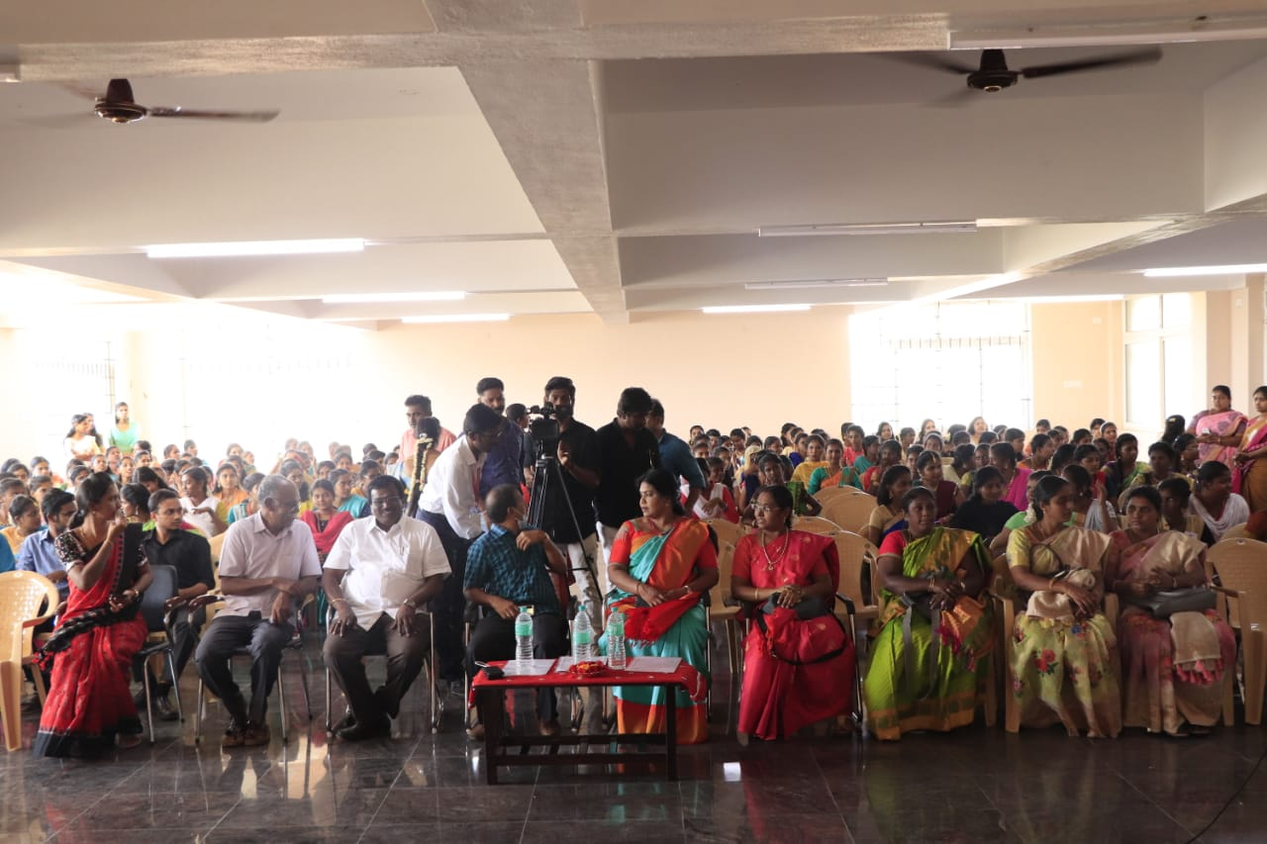

expressed their views on the given topic and both the family and society which are interlinked together should pave way for women to become innovative women. Out of nine participants three student got prize. The Mehandi competition was followed by Debate. Twenty seven students participated in the Mehandi Competition.

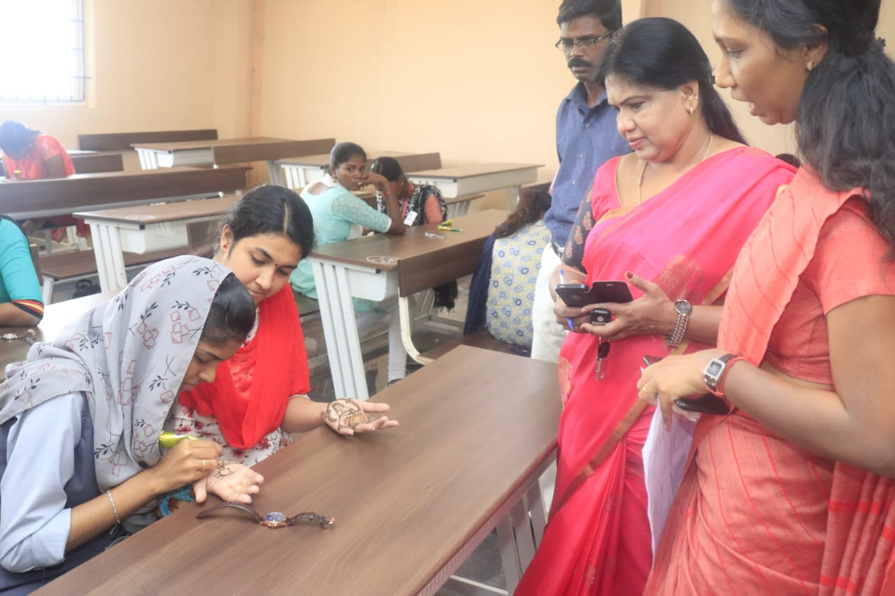

The student’s creative thoughts can be observed in the competition. The next event after the Mehandi competition is Dance Competition. Folk Song is the topic for dance competition. Thirty six students participated in the competition.

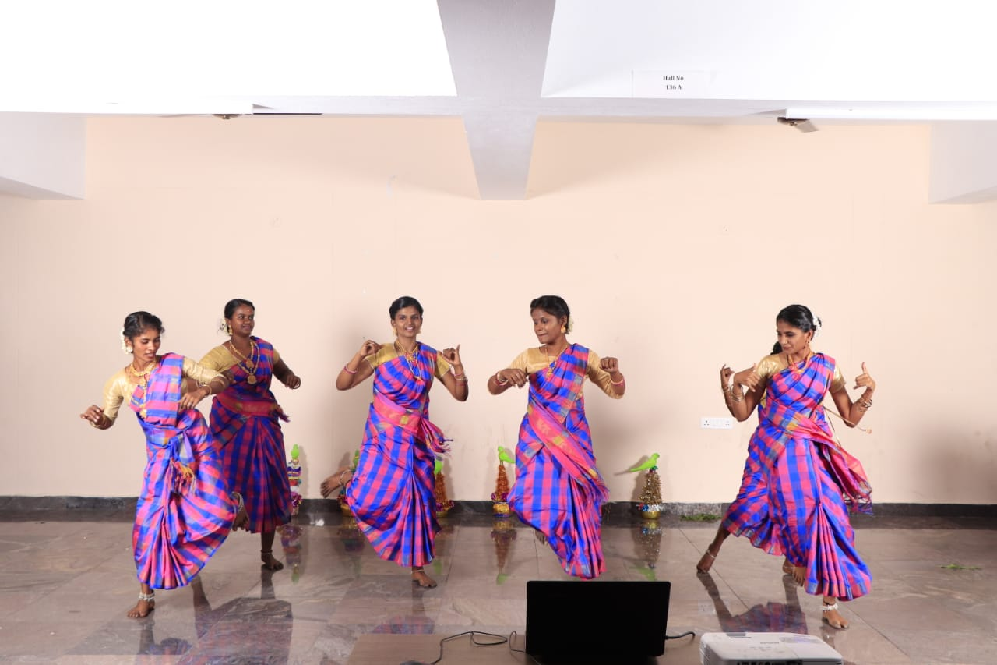

The dance was a cultural feast to the eyes of the people who watched the program. Seventeen students got prize in the competition. The dance competition was followed by Fireless Cooking as the meaning goes by its name. Fireless cooking is a traditional cooking method of preparing food without

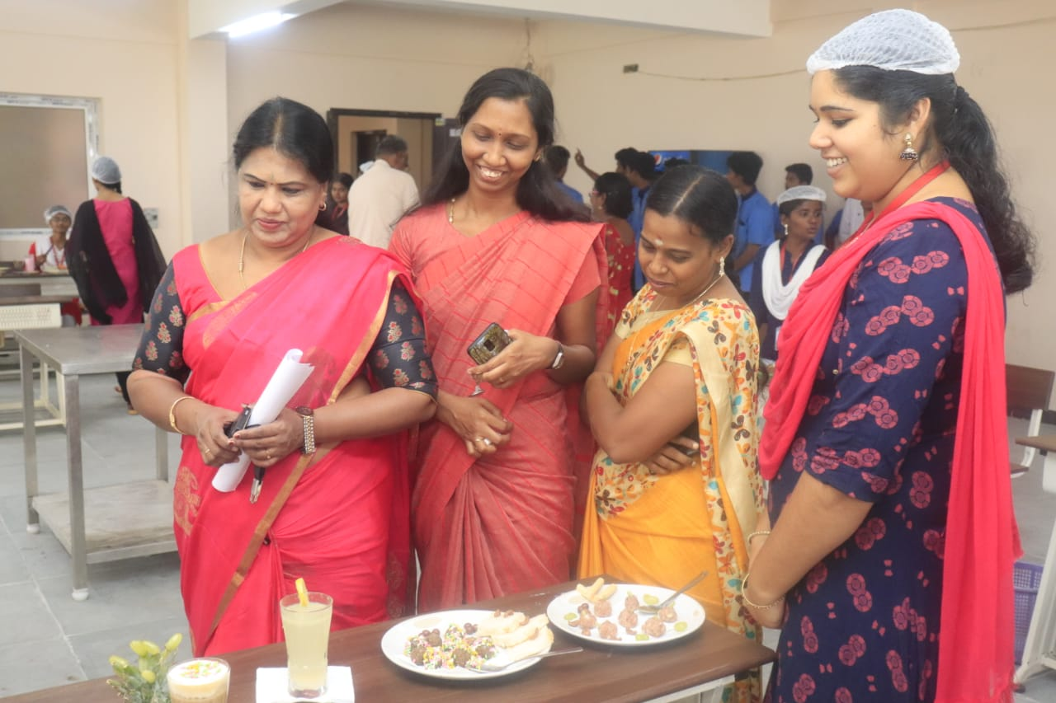

fire. Fourteen groups participated in the cooking competition. Two members consisted of a group. Out of Fourteen groups three groups got selected in the competition. The next event was Rangoli .The Title of the Rangoli competition was “Varalatrin Sakthi”; Meaning historical power. Nine groups participated in the competition. Three groups got selected in the competition. All these events exposed the importance of women their potential to achieve what they desire. Prize were distributed for the winners in the events by Dr.N.Jagatheesan the Correspondent and Secretay of Naagarathinam Angallamal Arts and Science College .

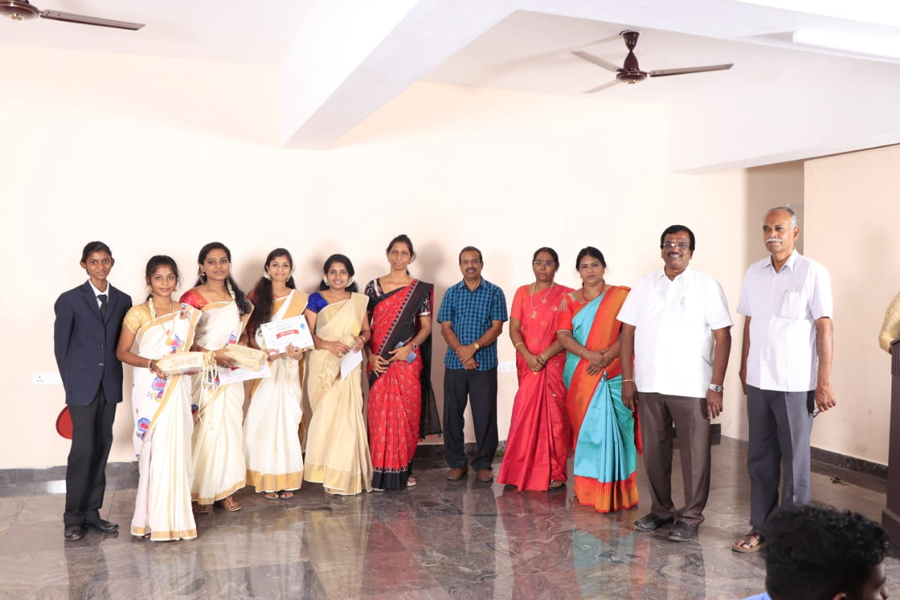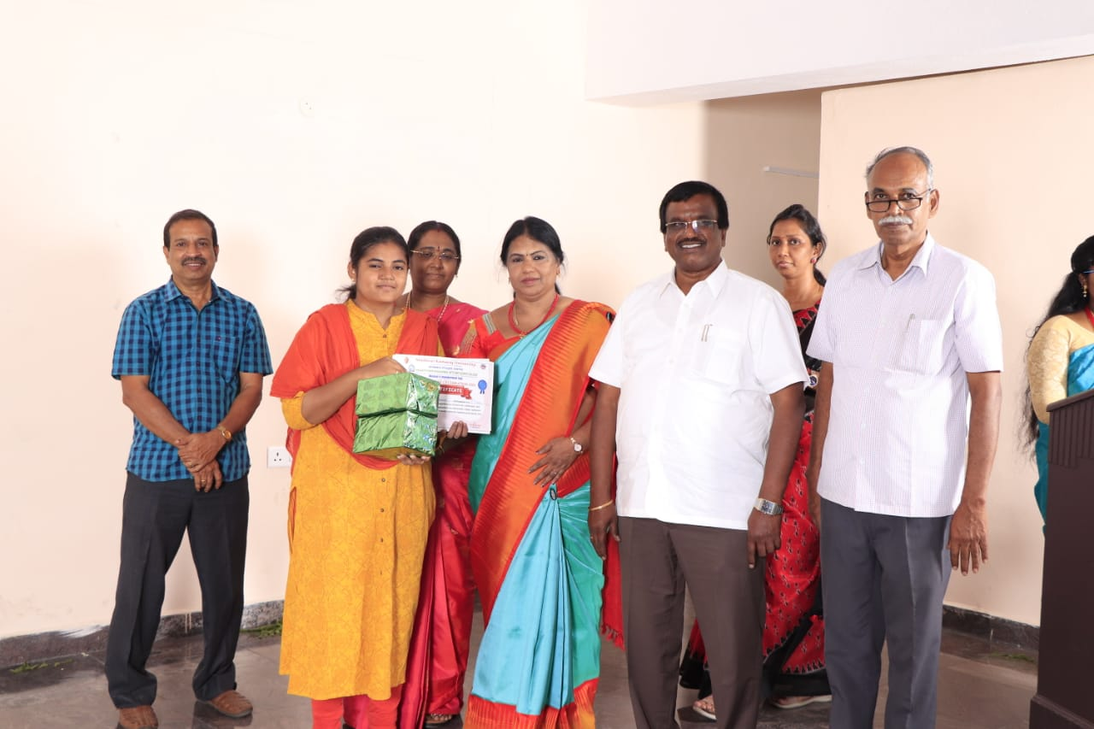

The Women’s day Celeberation ended with the release of Trailer of the Short film named “podhimalai” by Ragalai Team. The film was about a working woman the heroine of the movie; the mother of two years old .Her husband fights with her to sign in the divorce paper which she refuses thinking of her child. She meets a old woman in a temple and asks the old woman about her house. The old woman says she lives in the temple alone and eats food from the people who visit the temple. The trailer ends showing the woman thinking about old woman and puts signature in the divorce paper. She goes to temple again with her child and come out of the temple together with the old woman.

